LAB 03

ROLL NUMBER: 23K-0526

QUESTION :01

OUTPUT:

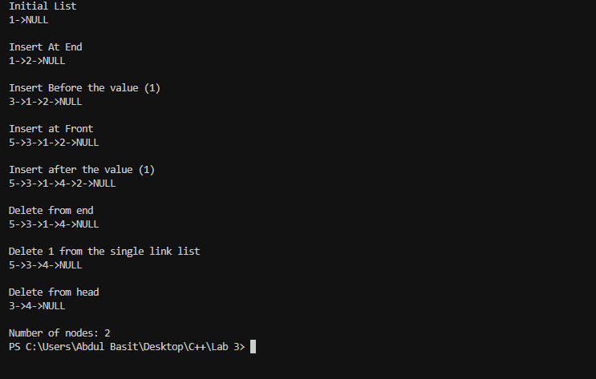

QUESTION: 02

OUTPUT:

QUESTION: 03  
  
OUTPUT:

QUESTION: 04

OUTPUT:

QUESTION: 05

OUTPUT:

